**Team Members:-**

* Mandeep Singh
* Anirudh
* Dalwinder
* Darshpreet

**Aim:-** To create a web based dashboard (with the use of d3) on **Crimes Dataset** provided.

**DATA VISUALISATION**

Data visualization is the graphical representation of information and data. By using visual elements like charts, graphs, and maps, data visualization tools provide an accessible way to see and understand trends, outliers, and patterns in data.

**D3** allows to bind arbitrary data to a Document Object Model (DOM), and then apply data-driven transformations to the document.

Here we are provided with the accidental data of city ROPAR at different areas.

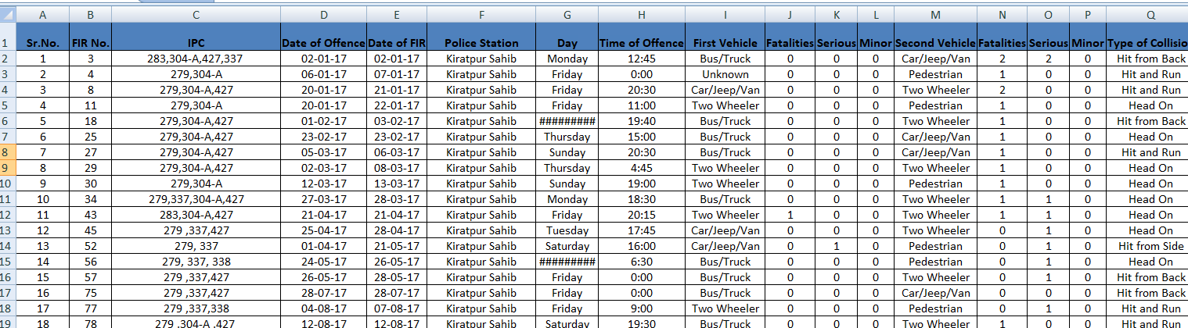

Load dataset in jupyter notebook and start with basic preprocessing operations.Fetch the different types of attributes from the data to start with the visualisation process.

In this given dataset following data is reterived from the excel sheet.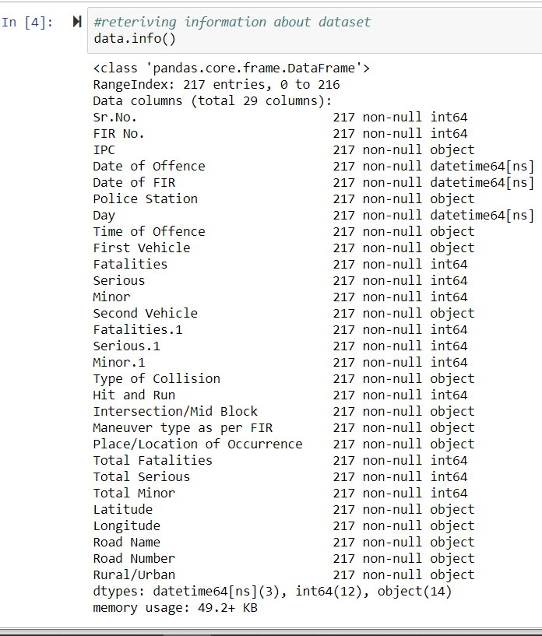

**RADIAL HEAT MAP**

A radial heat map is a variation of heat map , where the table is aligned radially. A heat map is a graphical representation of data where the individual values contained in a matrix are represented as colors.

In this dataset to create radial heat map columns selected were --

* 'Type of Collision'
* 'Police Station'
* 'Total Fatalities

Further type of collision and police station were divided into different types.

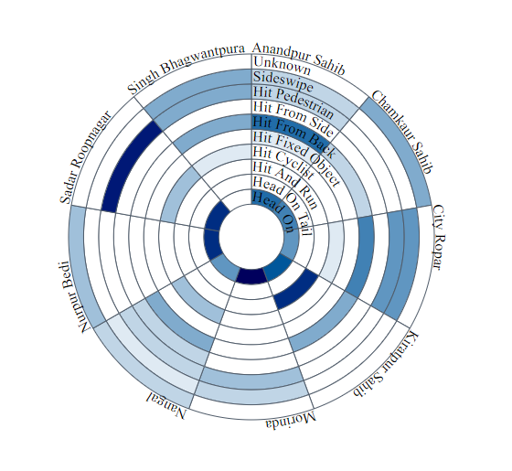

**BUBBLE CHART**

A bubble chart is a variation of a scatter chart in which the data points are replaced with bubbles, and an additional dimension of the data is represented in the size of the bubbles.

In bubble chart following columns were taken

* 'Rural/Urban'
* 'Maneuver type as per FIR'.

These were renamed as:-

'Rural/Urban' --'rural_urban'

'Maneuver type as per FIR'--'fir_types'

A third additional column of count was added to count the number of particular FIR’s .

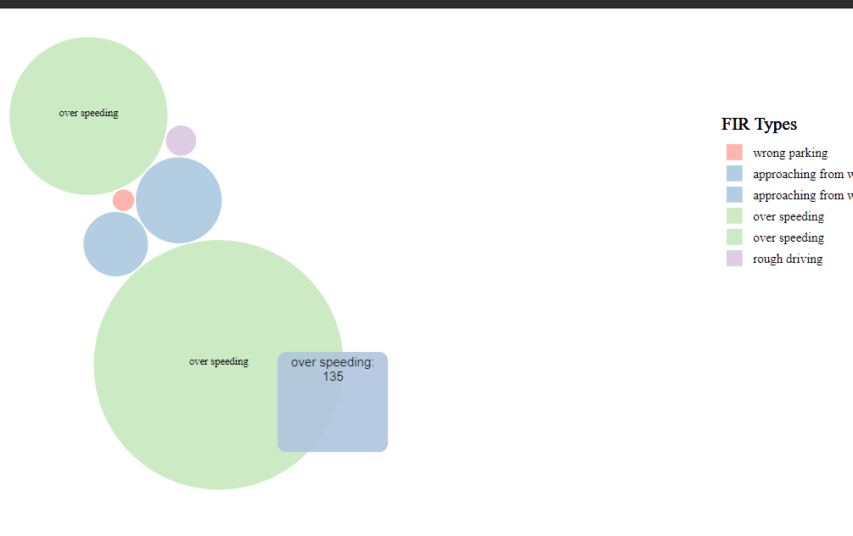

**BAR CHART**

A bar chart or bar graph is a chart or graph that presents categorical data with rectangular bars with heights or lengths proportional to the values that they represent. The bars can be plotted vertically or horizontally.

In bar chart following columns are taken:

* Police Station
* Date of FIR
* Date of Offence

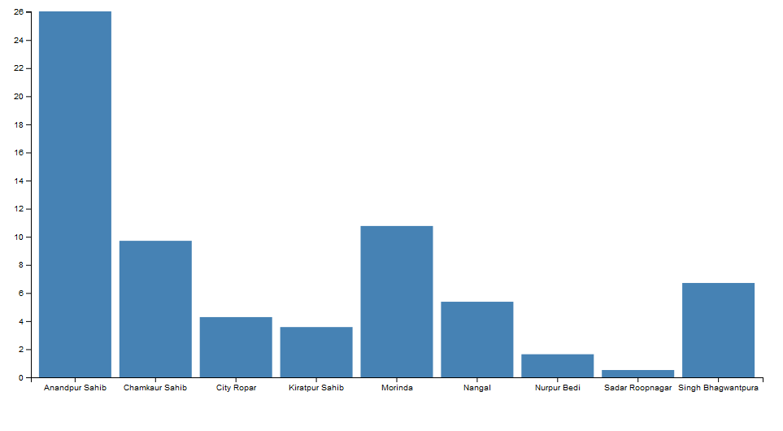

**FOLIUM**

Folium builds on the data wrangling strengths of the Python ecosystem and the mapping strengths of the Leaflet.js library. It helps manipulate data in Python and then visualize it in a Leaflet map via folium.

There are two maps in the following screenshots.

The accidents are mapped based upon place of accidents i.e. Rural and Urban.

And the other mapping depicts the police station under which the area of accidents falls.

By hovering on the markers, one can get details of the place of occurrence of the accident and on clicking the police station under which the place falls appears.

One can get a fair idea of where the maximum number of accidents occur by visualizing the cluster of markers. Based upon the police stations, the markers have been color coded as per the number of police stations.

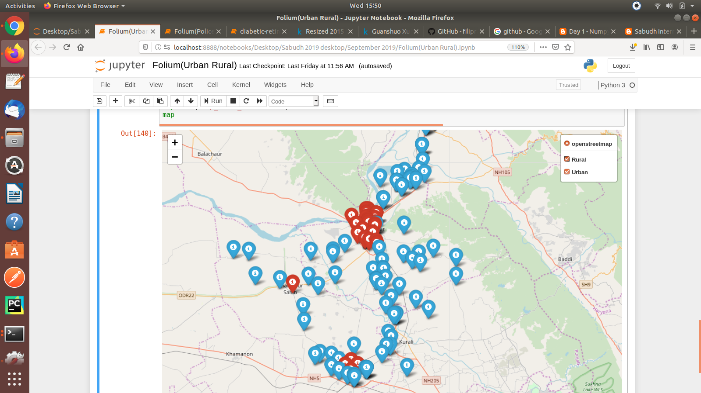

The above map classifies the accidents as Urban and Rural based upon the place of occurrence.

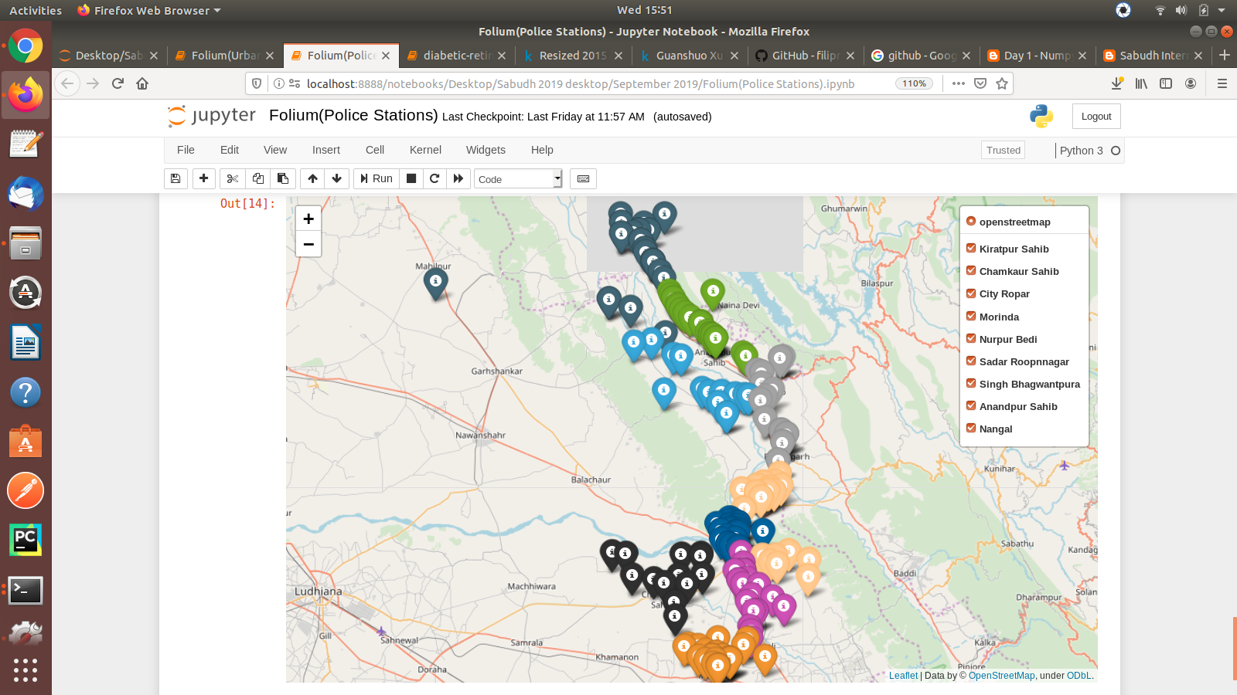

MAP depicting the markers where accidents took place and the different colors are used for different police stations. One can get the place of accident by hovering on the marker and can get the police station under which the location falls by clicking on the marker.